Learning Project WEEK 3- Celebrations
Age Range: EYFS
Weekly Maths Tasks (Aim to do 1 per day) | Weekly Reading Tasks (Aim to do 1 per day)
- Play this game to practise counting, ordering and matching numbers to 10.  - Practise counting up to 20+. This can be done through playing hide and seek, singing number songs, chanting, board games etc.  - Listen to a number song from the CBeebies website. After listening to them, watch again and sing along if you can. Talk about the maths you can see in the video clip.  - Make a selection of birthday cards with numerals on the front. Can your child count out birthday candles (if you have them available or cut up straws to represent them) or objects to match the amount? Can they order the numerals from the smallest amount to the largest?  - Play snap using the digit cards 1-10, then 1-20 (provided). Say each number as you present it to your snap partner. Can you make a 1-20 number line? Ask your grown up to hide some numbers on the number line by turning them around. What’s missing? | - Use the Small Talk website for ideas on supporting your child’s Communication and Language development.  - Read together the fact sheet on ‘Victory in Europe Day’. Discuss together. Is there anyone you know who served in the war?  - Reception age children: Children to read to parents daily. Visit Oxford Owl for free eBooks that link to your child’s book band -pink, red, yellow  www.oxfordowl.co.uk/ login - wsr12 bcps  - With your child, look in magazines, newspapers and books for the tricky words they are currently learning. They could use a highlighter to highlight in magazines and newspapers. Use the tricky word songs to help too.  www.youtube.com/watch?v=R087lYrRpgY
Weekly Phonics Tasks (Aim to do 1 per day) | Weekly Writing Tasks (Aim to do 1 per day)
- Daily phonics - Practice the sounds your child is working on and blend words. This can be oral blending (e.g. spoken out loud c-a-t) or written if appropriate. Use Interactive games on Phonics Play.  - Use Teach Your Monster to Read an interactive game to support phonics & reading activities.  www.teachyourmonstertoread.com/  - Fireworks are often used during different celebrations. Watch a video of a fireworks display. Can your child explore using instruments (if available) or household objects e.g. pots and pans to make their own imitation of firework sounds.  - Learn the song ‘On Bonfire Night’ and encourage your child to make marks to represent the sounds in the song e.g. whiz, whiz could be a swirling pattern. | - Practice forming the letters of the alphabet using your handwriting mat and pen. The website below can support too.  wwdrwww.teachhandwriting.co.uk/handwriting-resources-children.htmlen.html  - Create a card for a celebration of your choice e.g Happy VE Day! Can your child use their phonics knowledge to write a message for the person they would like to give it to?  - Ask your child to draw a picture of a celebration they have taken part in. Encourage them to use their phonics knowledge to write about their memory of that day.  - Ask your child to write out the tricky words they are working on at the moment on pieces of paper and turn them into a pairs game or use the laminated ‘look, cover, write check’ boards.  - Plan a celebration for your toys or family for the end of the week e.g. to mark VE Day – a garden tea party!. Write a list of things that you need for the celebration e.g. hats, cake, gift, invitations etc.
Learning Project - to be done throughout the week
This project this week aims to provide opportunities for your child to learn more about celebrations, including the forthcoming VE Day celebrations. Learning may focus on different types of celebrations that take place and who may celebrate them. It could look at how people celebrate different events differently in other parts of the world.
- Family Photographs-
  - Look over a selection of photographs of family celebrations and discuss with your child: what the celebration was about, who attended, what you did to celebrate, when it took place, whether it is an event that happens each year. Can your child remember the event taking place? What do they remember of it?
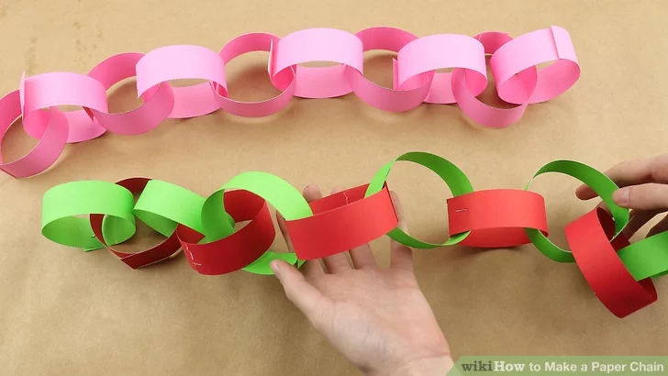
- Plan a family celebration-
  - Decide on a family celebration for the week. This could be a family indoor picnic, meal, dance etc. Ask your child to write invitations to family members to the party.
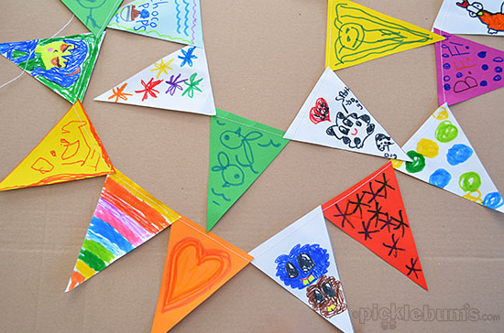
  - Create homemade decorations using coloured paper (If you do not have coloured paper at home, you could use old newspaper or wrapping paper) You could make paper chains or bunting
  - Plan a menu for the party and make the food together.

- Discover religious celebrations-
  - Watch the Let’s Celebrate video collection for Easter. Discuss the celebrations with your child. How did you celebrate Easter? Which of the events did they take part in?

  - Watch the Let’s Celebrate video collection for Eid-al-Fitr. Discuss the celebrations with your child. Did they celebrate Eid-al-Fitr? How did they celebrate? Are there any similarities and differences between the celebrations they saw in the Easter videos?

  - Look through the range of videos available on Cbeebies and watch together. Discuss who celebrates the event and any similarities and differences with celebrations your child has taken part in.

- VE Day-
  - Make a flag to use on VE Day. This could be of the British flag.
  - Wear red, white and blue for the day.
  - Make some of the Wartime Recipes (provided) as part of any VE Day celebrations. Talk about how some food was not readily available and how people had to be creative!
  - Colour a VE Day picture (provided) or draw your own of your family celebrating.
Additional learning resources parents may wish to engage with
Classroom Secrets Learning Packs - These packs are split into different year groups and include activities linked to reading, writing, maths and practical ideas you can do around the home.
Twinkl - to access these resources click on the link and sign up using your own email address and creating your own password. Use the offer code UKTWINKLHELPS.
Hamilton Trust -These packs are split into different year groups and include activities linked to reading, writing, maths and practical ideas you can do around the home.
#TheLearningProjects

