Prayer Space Day 3: Commitment to the Vision

We further explored our vision, ‘Know that I am always with you.’ One group looked at the ‘Footprints in the sand’ poem and how God is with us in bad times. Children wrote on footprints about times when God had carried them or someone they knew. Some children asked God to help someone.
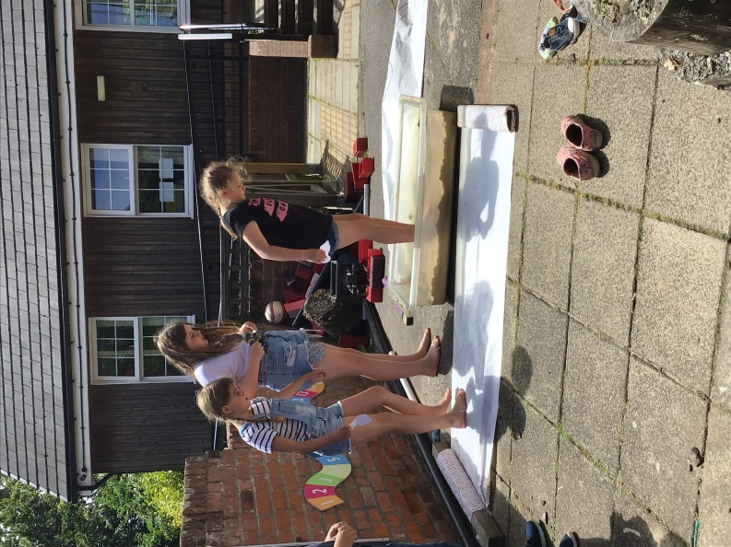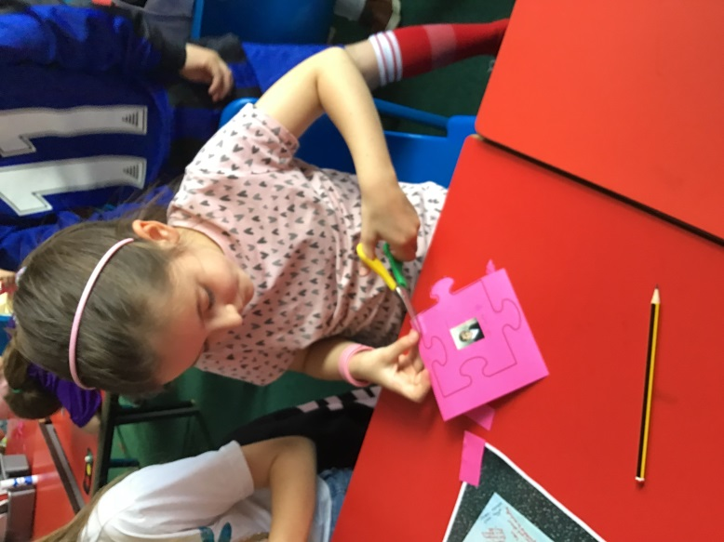
We also made a commitment to our vision in the shape of a promise rainbow, where all our promises for how we would change, fitted together as jigsaw pieces to make the rainbow.
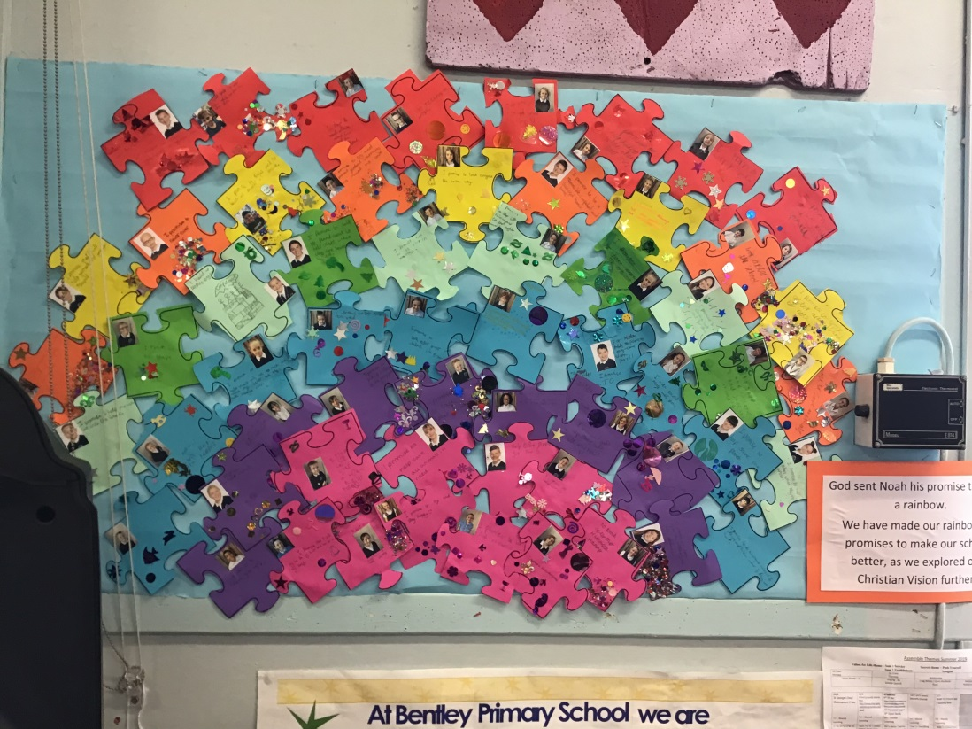
The children have also designed an altar cloth to represent the vision, to use in church. The lucky winner’s design will be made over the summer.
We ended with a commitment outside, and sent some prayers to God by blowing bubbles during a silent prayer.
